Minutes of COCTYC Meeting
194th 2YC₃ Conference
Montgomery College, Rockville, MD
November 12, 2011

Members in attendance: Jeffery Cramer (Past Chair/DivCHED rep), Julie Ellefson-Kuehn (Treasurer/College Sponsors), Jason Jadin (Chair-elect 2011), Lance Lund (Past Chair/RAB Coordinator), Mark Matthews (Chair), Candice McCloskey (Past Chair/Future Sites), Luca Preziati (Webmaster)

Members absent: Pam Clevenger (Chair-elect 2012, non-voting member), Tom Higgins (Membership), Jim Schneider (Newsletter), Michele Turner (Industrial Sponsors)

Guest: Joan Sabourin (ACS Office of Two-Year Colleges)

Pre: Motions made via email since Brevard Community College meeting:
September 30, To approve MiraCosta College as the site for the 195th Conference.
- Seconded and passed unanimously
September 30, To approve the minutes from the 192nd COCTYC meeting.
- Seconded and passed unanimously

October 5, To approve Neil Bastian's and Thom Jose's applications for 2014 chair.
- Seconded and passed unanimously

October 26, That the COCTYC cancel the May 25-26, 2011 meeting at Borough of Manhattan Community College, NY.
- Seconded and passed unanimously

- Meeting called to order by Mark at 2:45 p.m.

- 193rd Conference Debriefing
  - The planning team addressed the group. The team mentioned that they had many institutional headaches, such as coordinating between the three campuses. The banquet ended up costing around $50 per person though they only charged $35 per person. They don’t know how they will recoup the loss. The total registration was 82. The conference attracted 2 new industrial sponsors. Industrial sponsors were not willing to provide financial support for refreshments.
  - The COCTYC members thanked planning team and all of the Montgomery College faculty members for a good conference. The planning team was reminded to complete the conference budget form, send presentation files to Luca, and send out the on-line conference survey.
- Approval of minutes from the 193rd COCTYC meeting (Brevard Community College):
a. The minutes were not available at the meeting for review. The minutes will be approved via email after the meeting.

- Treasurer Report
  - The report is found in Appendix 1.
  - At the time of this meeting, the organization has a $4000 surplus even though we lost money on the t-shirts, have not received money from CHED, or all sponsor and membership dues collected at conferences.
  - 2YC₃ membership numbers from the treasurer and membership chair are not matching.

Action Item: Julie and Tom will work to correct the discrepancy.

  - Brevard Community College did not request any seed money.
  - The draft budget was presented. The income from advertisements was kept the same as last year. Paypal and Go Daddy were added as expenses under sponsors and members.

Motion: To approve the COCTYC/2YC₃ budget for next year. Seconded and passed unanimously.

  - The organization needs to prepare for an audit.
  - If an officer uses their own vehicle for travel to a conference, the individual will be reimbursed the current IRS mileage rate up to the cost of airfare and car rental fees.

- College Sponsor Report
  - The report is found in Appendix 2.
  - There are currently 80 college sponsors.
  - The goal is to reach 100 college sponsors.

- Future Sites
- The report is found in Appendix 3.
- The MiraCosta Community College conference is a go.
- Dan Stanford is the program chair for the 197th conference.
- The 196th conference is vacant. The idea of a virtual conference was brought up to fill this spot. Many questions remain on how we can pull this off.

Action Items: Mark will set-up a Doodle poll to see when COCTYC members are available to test the available software for a virtual conference. Lance and Joan will look into the use of software programs. Lance will do a 10 minute presentation during our test of the software.

- Many questions still remain and need to be answered about the Canada conference. How do we coordinate finances, registration, and calls for papers?

Action Item: Candice needs to contact Geoff and discuss these issues.

- RAB Report
  - The report is found in Appendix 4.
  - The RABs are currently working on updating the two-year college chemistry instructor database.
  - Several attendees expressed interest in becoming a RAB member.

Motion: To appoint Owen Lofthus, Veronica Stein, and Nancy Thorpe to the Eastern RAB. To appoint DeeDee Allen to the Southern RAB. Seconded and passed unanimously.

- Webmaster
  - The report is found in Appendix 5.
  - The 192nd and 193th archives have been added to the website.
  - Luca is working to fix a glitch in the auto update for membership expiration dates.

- DivCHED Report:
  - Jeff reported that the Division would like attendees to accept the ACS safety statement when registering for conferences and that the conference planning manual should have a safety statement.

Action Item: Jeff will write the safety statement for inclusion in the conference planning manual.

  - The Division is planning a financial audit for the exams institute, COCTYC, BCCE, and publications.
  - No action has been taken on the COCTYC’s request for an addition allocation of $2000.
  - The Policies and Procedures document should be amended to include the duties of the 2YC₃ program chairs for BCCE. The COCTYC feels it should be able to appoint at least one 2YC₃ program chair and the BCCE committee can appoint the other chairs.

Action Item: Mark will ask Thom Jose and Michele Turner if they would be willing to write a description to be included in the Policies and Procedures document.

- Membership
  - No report was given.

- Industrial Sponsor Report
  - Pearson has renewed their sponsorship and the check is in the mail.
  - Two new sponsors were at this conference.

- Newsletter Report
- No report was given.

- New Business
  - Julie’s term as treasurer/college sponsors chair ends December 2012. She indicated her willingness to serve a second term.

Motion: To appoint Julie to a second term as treasurer/college sponsors chair. Seconded and passed unanimously.

  - The role of the COCTYC and the SOCED Task Force on Activities in the Two-Year College was discussed. The committee agreed it would be involved as the primary stakeholder in the Workshops group and would be willing to provide some financial support.

Action Item: Jason will write the COCTYC’s recommendation to the SOCED task force.

c. Mark thanked Jeff for his 9 years of service to the COCTYC.
d. Lance thanked Mark for the leadership during this past year.

- Old Business
  - None.

- Meeting was adjourned at 6:30 p.m.

Future ACS National Meetings (from the ACS website)
- 243rd ACS National Meeting & Exposition
March 25-29, 2012
San Diego, California
- 244th ACS National Meeting & Exposition
August 19-23, 2012
Philadelphia, Pennsylvania
- 245th ACS National Meeting & Exposition
April 7-11, 2013
New Orleans, Louisiana
- 246th ACS National Meeting & Exposition
September 8-12, 2013
Indianapolis, Indiana
- 247th ACS National Meeting & Exposition
March 16-20, 2014
Dallas, Texas
- 248th ACS National Meeting & Exposition
August 24-28, 2014
San Francisco, California
- 249th ACS National Meeting & Exposition
March 22-26, 2015
Denver, Colorado
- 250th ACS National Meeting & Exposition
August 16-20, 2015
Boston, Massachusetts

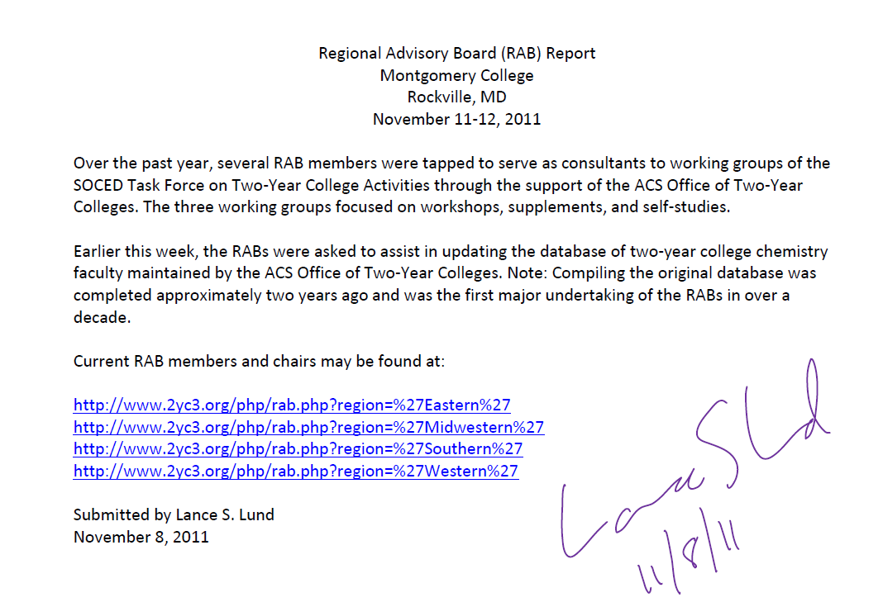

Webmaster Report
November 2011

Completed as of September 2011:
- The registration form for the 194th conference is now online.
- A new page has been created for the 192st conference archives
- Industrial sponsors, newsletters, and many other areas of the website have been updated
- The “Industrial Sponsors” section has been moved to the database system.
- The “RAB” section will has been moved to the database system.

Tasks in progress:
- The “College Sponsors” section will soon be moved to the database system.
- A new page is being created for the 193rd conference archives
- A new page is being created for the 190th conference archives
- There is a problem with the automatic update of the membership’s expiration dates. A few members paid for their 2012 membership before October 2011 but their expiration date did not get updated yet. The problem will soon be fixed.

Luca Preziati.
2YC3 Webmaster

